Name: ______________________________________ | Date: ___________________


Part 2: Cheerleading Headgear Assessment

Part 2: Designing an Optimal Solution
Here are three different headgear devices used for cheerleading that you reviewed in part 1 of this assessment.
 | 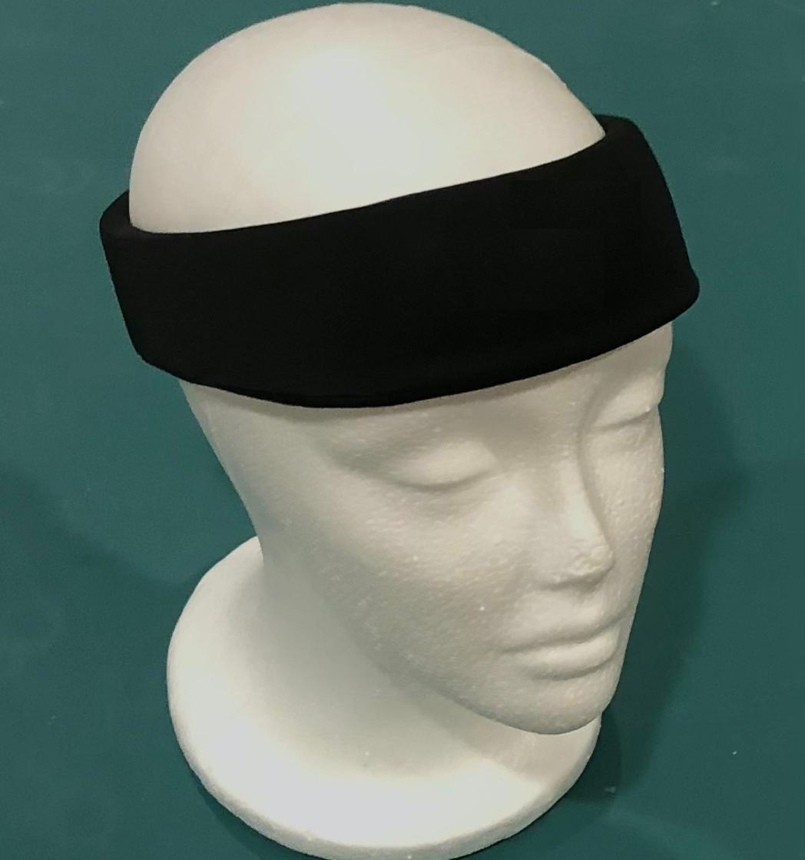 | 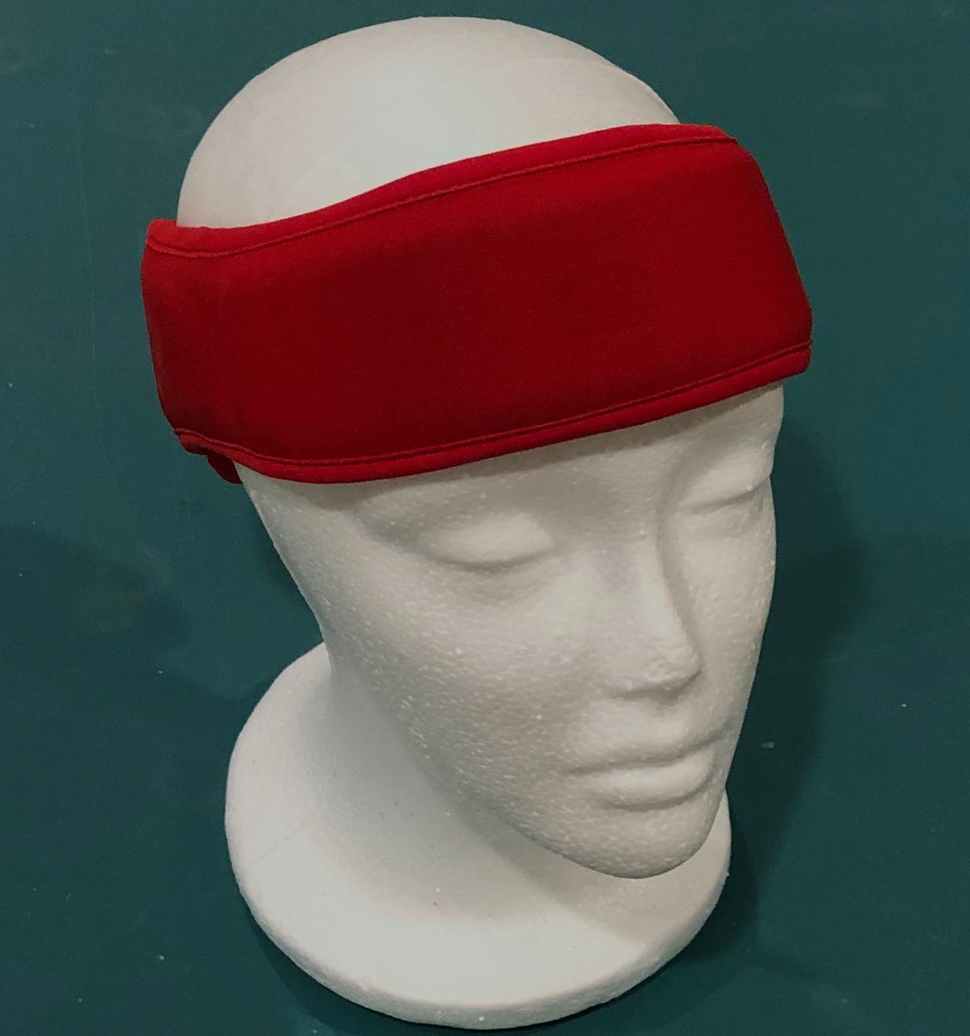
  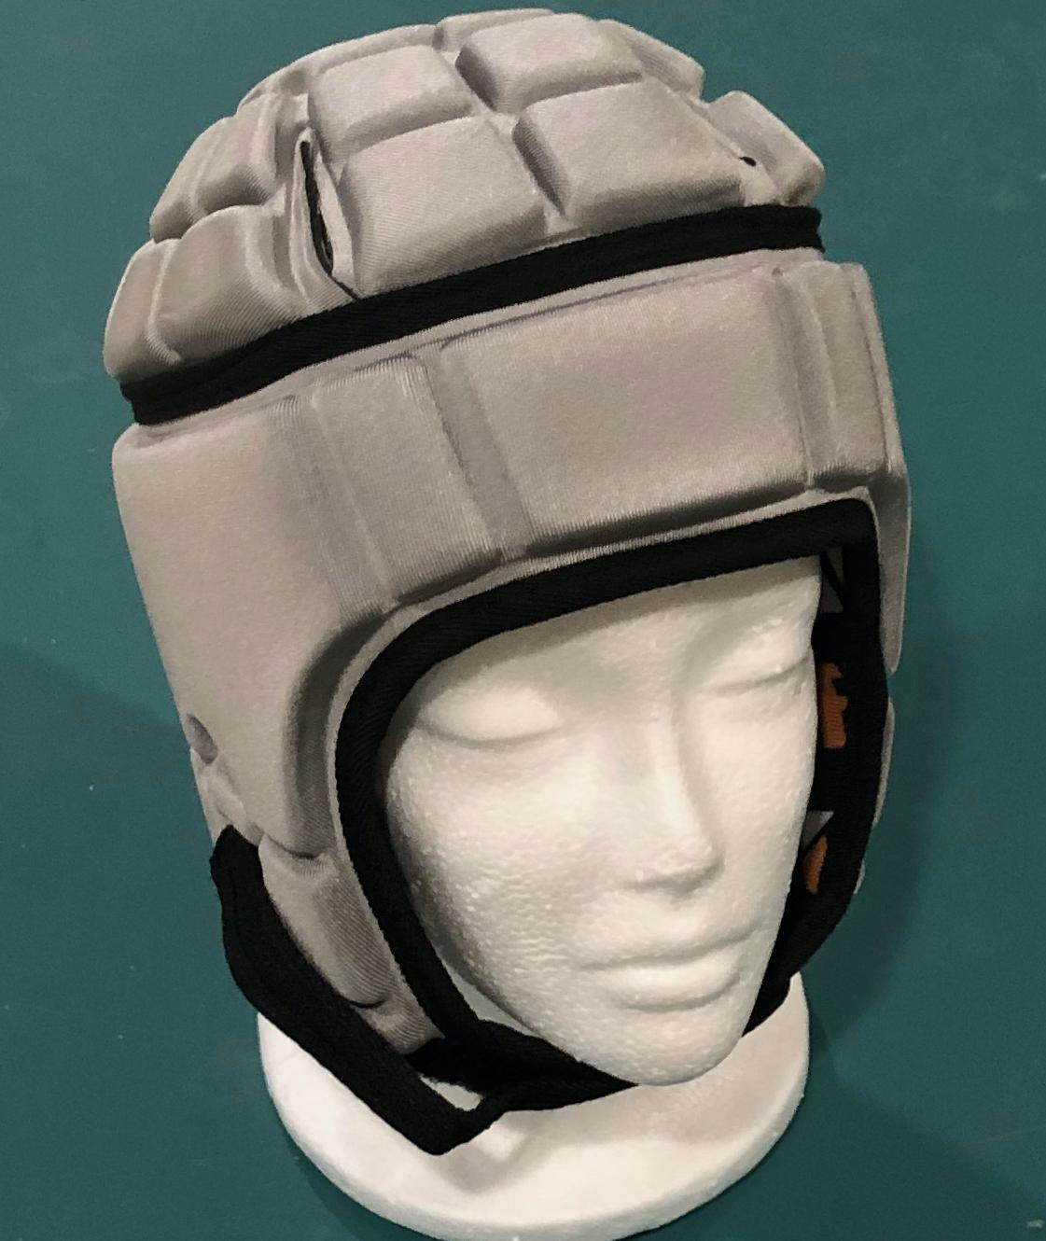
Design #1 | Design #2 | Design #3

These headgear devices were initially designed for other sports and then later people started using them for cheerleading. In competitions, cheerleading teams can earn points for more-advanced stunts and showmanship. The higher and more complex the throws and gymnastics, the more potential points can be earned by a team. Teams are also given points for engaging the crowd and overall appearance of the team.

Your task is to create an optimal headgear design for a cheerleader to wear in a competition. Complete the prompts on the next page to describe your design choices.

Considerations for design

1. What is the purpose of the design? What criteria does the headgear you design need to meet?

2. Pick one stakeholder who will be affected by your design and design with that person in mind.
- Who is the stakeholder you are designing for?
- What constraints do you anticipate your stakeholder will bring to your design? List at least 3 constraints that you think a helmet designer would have to consider.

Your design
3. Use words and pictures to show the structure of your design solution. In your design solution, make sure to label the different parts and materials used in the structure. Draw the proposed design on, over, and around the 2 views of the head shown below.

 | 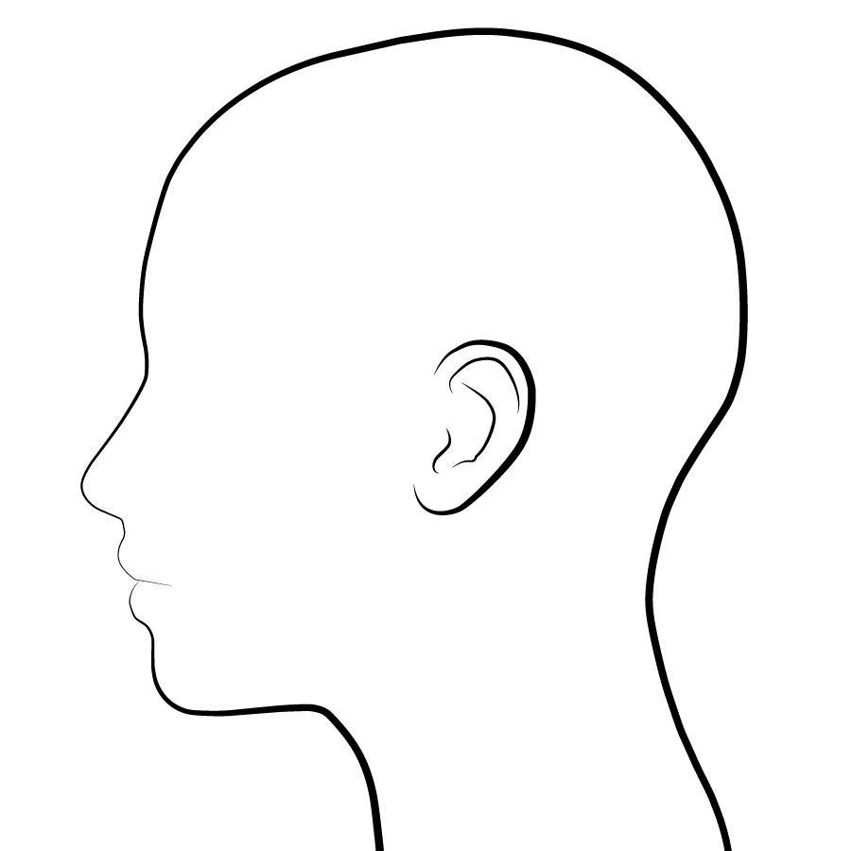

4. Explain how the materials in your design in #3 will function to reduce peak forces on a team member’s brain in a collision. Describe how any smaller-scale structures (small and microscopic) that make up your materials help contribute to their function.

5. Write an argument for why your design solution is optimal and meets the needs of your stakeholder. If you made trade-offs, discuss what trade-offs you made and why. [As an alternative to writing your argument, you can use this space to prepare to present your explanation orally instead. Think about any imagery (diagrams, pictures, drawings) you want to include in your presentation and how you will convey all the components of your design solution (why it is optimal and meets the stakeholder needs). If you choose this route, make a plan with your teacher for when you can present your explanation.]

